SciTech's ST-001 NanoFenretinde Fenretinide Drug Mechanism of Action (MOA)

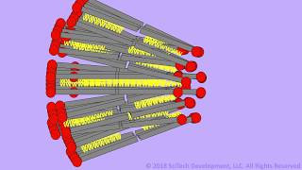

YouTube URL: https://www.youtube.com/embed/tsx8jNVZbO8
Description: The mechanism of action for SciTech's lead anti-cancer drug ST-001 nanoFenretinide, a nanoparticle fenretinide formulation in a phospholipid matrix. For more info visit http://www.scitechdevelopment.com
Video Transcript: The active drug in yellow is held within a sandwich of phospholipids called a bilayer. These lipid bilayers stack in multiple layers just like onion peels to form tiny spheres or balls known as nano vesicles. The vesicles are so tiny they're visible only by an electron microscope and measure around 100 nanometers, about 1000 times smaller than the width of a human hair. This drug formulation, known as ST-001, is designed for injection into veins where the bloodstream distributes it throughout the body including cancerous tissue. The drug then enters individual cancer cells shown in brown and eventually reaches the nucleus shown here in yellow. Within the cancer cell the drug triggers different processes including one that leads to breaking up of the nucleus, a process known as apoptosis. The entire cell eventually disintegrates completely. Studies have shown however that normal healthy cells are not affected by fenretinide.

For investment and partnering opportunities contact Earle Holsapple | (313) 263-4887 | eth@scitechdevelopment.com

